**YEAR 12 CHEMISTRY ATCHE **

**TEST 5**

**Synthesis**

**Recommended time: 30 minutes**

**/20**

Name: _____________________________________________________

Teacher: _____________________________________________________

This test consists of two (2) parts. Attempt ALL Questions.

**Section 1:** Multiple choice style consisting of TEN (10) questions.

Each question is worth 1 mark.

Write your answers on the **Multiple Choice Answer Sheet** provided.

**Section 2:** Short Answer style consisting of TWO (2) questions worth 10 marks.

Write all answers in the spaces provided.

The marks allocated to each question are shown at the foot of each question.

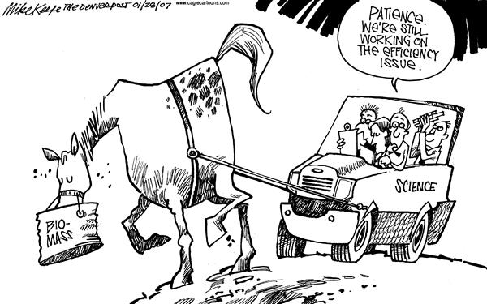**YEAR 12 Synthesis Test SEMESTER 2, 2018**

**MULTIPLE CHOICE ANSWER SHEET**

**Mark /10**

**Student Name: ____________________________**

**Teacher Name: ____________________________**

**INSTRUCTIONS**

For each question shade the box to indicate the answer. Use only a blue or black pen to shade the boxes.

For example, if b is your answer:-

1. a □ b ■ c □ d □

If you make a mistake, place a cross through that square and shade your new answer. Do not use correction fluid. For example, if b is a mistake and d is your answer:-

1 a □ b ■ c □ d ◼

Should you wish to change your answer back to your first answer, place a circle around the answer you wish to be considered correct by the marker. For example, if you decide that b is the correct answer:-

1 a □ b ■ c □ d ◼

|  |  |
| --- | --- |
| 1 | a □ b □ c □ d □ |
| 2 | a □ b □ c □ d □ |
| 3 | a □ b □ c □ d □ |
| 4 | a □ b □ c □ d □ |
| 5 | a □ b □ c □ d □ |

**Section 1 Multiple Choice (5 marks)**

Place your answers on the grid on the previous page, following the instructions above the grid.

1. Polyethylene terephthalate (PTE), otherwise known as polyethene terephthalate, Dacron or Terylene is a polymer. Part of its structure is shown below.

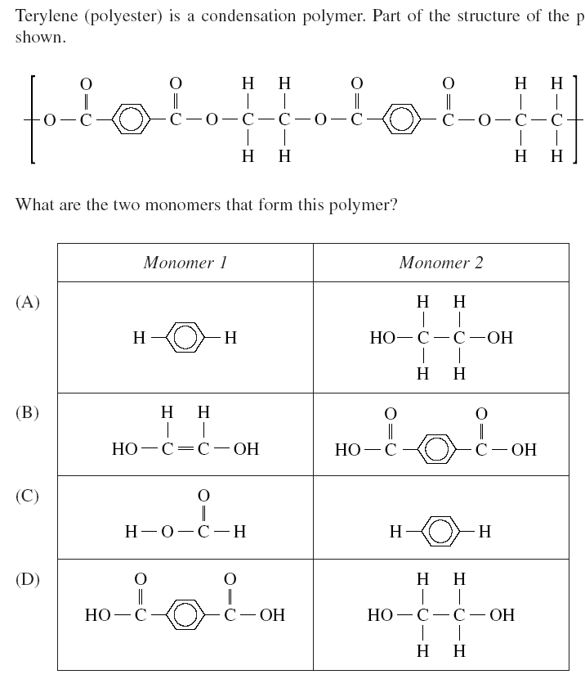

1. Which of the following monomer(s) would most readily produce a condensation polymer?
2. HOOC(CH2)2COOH and H2N(CH2)2NH2
3. C2H4
4. C2H5COOH and C2H5OH
5. CH3CONH2
6. Which of these polymers is NOT an addition polymer?

|  |  |
| --- | --- |
| Polymer I  http://2.bp.blogspot.com/-oA-xhkivPp0/TrdFea6_8ZI/AAAAAAAABN0/Wfr7DfA0joo/s1600/formula+1.jpg | Polymer IIhttp://www.essentialchemicalindustry.org/images/stories/100_biotech/10-biotechnology_Fadc.jpg |
| Polymer III  https://upload.wikimedia.org/wikipedia/commons/e/e4/Molecular-Structure_Liquid-Crystal-Polymer-(LCP)_Jaybear.png  Note: x and y are another way of stating that each of these parts is repeated n times, where they may not be repeated equally ie x could be a smaller or larger number than y) | Polymer IV  http://www.nature.com/article-assets/npg/srep/2013/130826/srep02502/images_hires/w582/srep02502-f1.jpg |

1. Polymer III only
2. Polymer IV only
3. Polymer I and IV
4. Polymer II and III
5. This question refers to stage 2 of the contact process:

2SO2(g) + O2(g) ⬄ 2SO3(g) + heat

Industrial Chemists deliberately lower the temperature of this reaction compared to stage 1 of the Contact process because:

1. A lower temperature increases the rate of the reverse reaction more than the forward reaction, so the yield of sulphur trioxide is increased.
2. A lower temperature is used because despite causing the forward reaction to slow down, the reverse reaction rate slows down more and this results in a smaller equilibrium constant.
3. Lowering the temperature is necessary because continued use of very high temperatures from step 1 is unsustainable and dangerous.
4. A lower temperature decreases the rate of the reverse reaction more than the forward reaction and produces an equilibrium constant that is larger at the lower temperature.

5. 5. The list below has similarities and differences between soaps and detergents.

i) Both soaps and detergents have a long, polar hydrocarbon chain.

ii) Detergents have a non-polar sulfonate group whereas soaps have a non-

polar carboxylate group.

iii) The polar group of both soaps and detergents form hydrogen bonds/ion-dipole

forces with water.

iv) The insolubility of the potassium salt of soaps makes them ineffective in hard

water, due to the formation of a “scum”.

v) The cleaning action of both soaps and detergents involve dispersion force

attractions between them and the dirt/grease/fat.

Which statements from the list are TRUE?

(a) i, iii, and v

(b) i, ii, and iv

(c) ii, iii, and v

(d) iii and v

**Section 2 Short Answer (20 marks)**

Write your answers in the space provided below each question.

1. The following structure shows an amino acid called ‘alanine’. (3 marks)

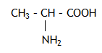

1. Draw the structure of the zwitterion form of alanine.

[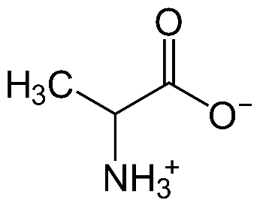](https://www.google.com.au/url?sa=i&rct=j&q=&esrc=s&source=images&cd=&cad=rja&uact=8&ved=2ahUKEwi_-fWWtJndAhUDMt4KHc0NCFYQjRx6BAgBEAU&url=https://commons.wikimedia.org/wiki/File:Alanin-Zwitterion.svg&psig=AOvVaw3najlFevmGN5WqOcH2Tj-7&ust=1535877628979271)

1. Draw the structure of alanine at pH 2 and pH 10.

|  |  |
| --- | --- |
| pH = 2  [Image result for alanine zwitterion](https://www.google.com.au/url?sa=i&rct=j&q=&esrc=s&source=images&cd=&cad=rja&uact=8&ved=2ahUKEwi_-fWWtJndAhUDMt4KHc0NCFYQjRx6BAgBEAU&url=https://commons.wikimedia.org/wiki/File:Alanin-Zwitterion.svg&psig=AOvVaw3najlFevmGN5WqOcH2Tj-7&ust=1535877628979271)  H  OH | pH = 10  [Image result for alanine zwitterion](https://www.google.com.au/url?sa=i&rct=j&q=&esrc=s&source=images&cd=&cad=rja&uact=8&ved=2ahUKEwi_-fWWtJndAhUDMt4KHc0NCFYQjRx6BAgBEAU&url=https://commons.wikimedia.org/wiki/File:Alanin-Zwitterion.svg&psig=AOvVaw3najlFevmGN5WqOcH2Tj-7&ust=1535877628979271)  NH2 |

2. 2. a) Below is the structure of a polyamide (polypeptide):

|  |
| --- |
| **H CH3 – CH – OH CH2SH**  **| | |**  **H2N – C – C – N – C – C – N – C – C – OH**  **| || | | || | | ||**  **H O H H O H H O** |

Using the data sheet provided identify the amino acids that make this polyamide and write their symbol in the box below, in the correct order (left to right). (3 marks)

|  |  |  |
| --- | --- | --- |
| **Glycine (Gly)** | **Threonine (Thr)** | **Cysteine (Cys)** |

b) If three amino acids polymerise in the order of serine, valine, alanine draw the structure of the polyamide that forms. (2 marks)

|  |
| --- |
| **CH2 – OH CH3 – CH – CH3 CH3 1 mark for polyamide**  **| | | 1 mark for AA order**  **H2N – C – C ––– N – C – C ––– N – C – C – OH**  **| || | | || | | ||**  **H O H H O H H O** |

3. Below are different pictorial representations of proteins, each one highlighting a different form (level) of protein structure. For each highlighted form, name the type of protein structure and name the type of bonding/interactions involved by filling in the table below.

|  |  |
| --- | --- |
|  | S:\AdminShared\E4153S01-Belridge SHS\All Staff\16 Current Data\Departments\Science\Year 11 & 12 Chemistry\001.jpg  **E** |
| **Lys – Phe – Asp – Glu – His – Trp**  **F** | S:\AdminShared\E4153S01-Belridge SHS\All Staff\16 Current Data\Departments\Science\Year 11 & 12 Chemistry\001.jpg  **G** |

|  |  |  |
| --- | --- | --- |
| **Highlighted section** | **Type of protein structure** | **Type of bonding / interaction involved** |
| **A** | **Tertiary** | **Dispersion** |
| **B** | **Tertiary** | **Ionic bonding** |
| **C** | **Tertiary** | **Disulfide link or Covalent bonding** |
| **D** | **Tertiary** | **Hydrogen bonding** |
| **E** | **Secondary/α-Helix** | **Hydrogen bonding** |
| **F** | **Primary** | **Peptide link or Covalent bonding** |
| **G** | **Secondary/β-sheet** | **Hydrogen bonding** |

(½ mark each = 7 marks)

1. The synthesis of sulfuric acid involves several steps:

Step 1: The formation of SO2

either: S + O2 ⭢ SO2 or 2ZnS + 3O2 ⭢ 2SO2 + 2ZnO

Step 2: The formation of SO3

2SO2(g) + O2(g) ⮀ 2SO3(g)

ΔH = –197 kJ mol–1

Step 3: Dissolving SO3 in water to produce oleum

SO3 + H2SO4 ⭢ H2S2O7

Step 4: Reaction of oleum and water to produce sulfuric acid

H2O + H2S2O7 ⭢ 2H2SO4

The second step can be affected by a number of factors;

Use Le Chatelier’s Principle to briefly comment on how the following factors are adjusted to achieve the maximum yield for the process: (2 marks)

a proportion of reactants.

**The ratio of SO2 to O2 is kept at 0.6 : 1.0, so that there is always an increased [O2].**

**This favours the fwd rxn in order to remove the extra O2, thus increasing the yield.**

b pressure.

The ratio of gases is 3:2, so that an increased pressure would favour the fwd rxn and increase the yield. (1-2 atm is not high, but there is no need for it as yield is >99% anyway)

1. The production of ethyl ethanoate from the starting material of ethene can be represented as a convergent reaction sequence as outlined below. Write the **name** and/or draw **full structural formula** as required, using the boxes provided, of the remaining four chemicals involved in the process in the correct order. (½ mark each)

ethene

ethene

**+ +**

**H2O H2O**

**↓ ↓**

**Structure:**

[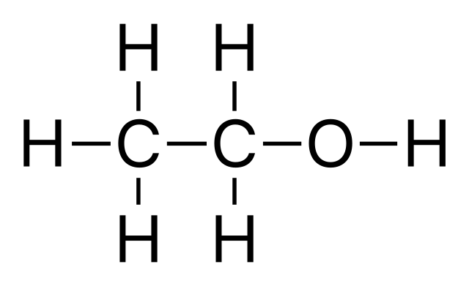](https://www.google.com.au/url?sa=i&rct=j&q=&esrc=s&source=images&cd=&cad=rja&uact=8&ved=2ahUKEwi-8vH6uJndAhWRE4gKHcv2CbkQjRx6BAgBEAU&url=https://commons.wikimedia.org/wiki/File:Ethanol-structure.svg&psig=AOvVaw2pTolax9E68iVBjNiY4pQy&ust=1535878912022090)

**Structure:**

[](https://www.google.com.au/url?sa=i&rct=j&q=&esrc=s&source=images&cd=&cad=rja&uact=8&ved=2ahUKEwi-8vH6uJndAhWRE4gKHcv2CbkQjRx6BAgBEAU&url=https://commons.wikimedia.org/wiki/File:Ethanol-structure.svg&psig=AOvVaw2pTolax9E68iVBjNiY4pQy&ust=1535878912022090)

**Name: Ethanol**

**+**

**K2Cr2O7**

**↓**

**Structure:**

[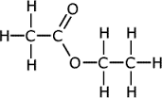](https://www.google.com.au/url?sa=i&rct=j&q=&esrc=s&source=images&cd=&cad=rja&uact=8&ved=2ahUKEwjFs83VuZndAhXUc3AKHa72DzcQjRx6BAgBEAU&url=https://www.meritnation.com/ask-answer/question/structure-of-ethyl-ethanoate/carbon-and-its-compounds/9773089&psig=AOvVaw14jhghlYQB-JR06Jd4YDHg&ust=1535879101630569)

**Structure:**

[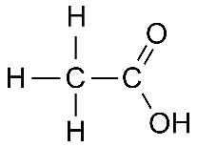](http://www.google.com.au/url?sa=i&rct=j&q=&esrc=s&source=images&cd=&cad=rja&uact=8&ved=2ahUKEwijisOjuZndAhUSFogKHZNWDDYQjRx6BAgBEAU&url=http://www.softschools.com/formulas/chemistry/acetic_acid/328/&psig=AOvVaw1Y76oip5amSe8PD4T5uVNI&ust=1535878998322399)

**Name: Ethanoic Acid**

**END OF TEST**